**XXX Study**

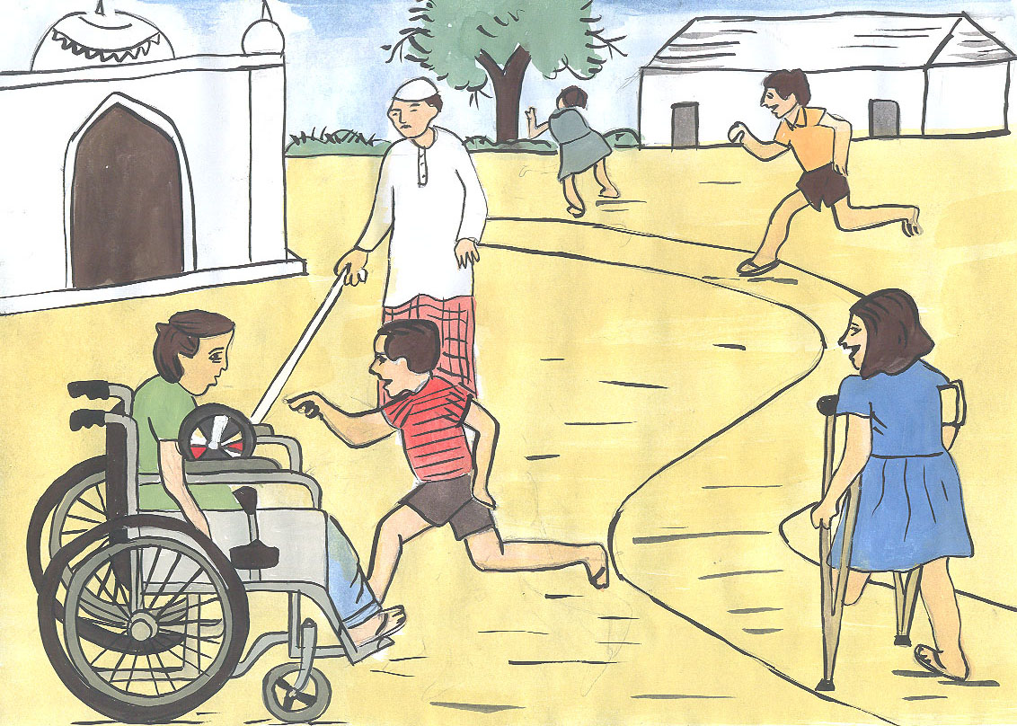

**What?** We are going to different parts of [Country] and trying to find children with disabilities to learn more about their lives. We would like to let a team of doctors talk to and examine you to see if you have any difficulties. We will also talk to you and your carers/parents about different things in your life, like whether you go to school, whether you are happy and whether you have been sick recently.

We will talk to you here, and It will take about 30-40 minutes.

**Do I have to take part?** No. It is up to you to decide whether or not to take part. You don’t have to answer the questions if you don’t want to. You can also stop me at any time if you don’t want to continue.

**Keeping the information private and safe.** We will be writing up everything you tell us and what the other children tell us, but we will not write down your name on any reports. It is very important to [organisation name] to keep children safe. If you do tell us something where we are worried about your safety we will share this with [organisation].

**Why are we doing this?** We will use this information to help plan to make better services for children with disabilities.

If you agree I will make a recording of what we say.

**If you want more information contact:**

*[organisation contact details here> Insert here*

*>> HELP Line Details>> To go here*

**Thank you!**

**